

**NATIONAL UNIVERSITY OF COMPUTER AND EMERGING SCIENCES**

PROJECT SLATE

**MAIN CAMPUS KARACHI**

**Department of Computer Science**

**Fall 2018**

**COURSE:**

**PROGRAMMING FUNDAMENTALS CS-118**

**COURSE INSTRUCTOR:**

**SIR MUHAMMAD SHAHZAD**

REPORT ON:

**TEAM LEADER: [18K-1254] SYED HAMZA BIN MAQSOOD**

**MEMBER: [18K-0366]   
SAYED MUSHAHID RAZA**

**MEMBER: [18K-1163] MUNEEB ASIF**

**12/10/2018**

A Flat-File Database System

Inspired from SLATE, we have decided to make our own model of a university’s learning environment. Based on a flat-file database that will hold the records of students and teachers' personal information, will allow them to make announcement and assignments, and share resources.

CONTENTS

Project Proposal 2

Program Code 2

Project References 2

Overview f the Program: 2

Overview of Tests Results 2

Rationale for Decision 2

Detailed Tests Results **Error! Bookmark not defined.**

### PROJECT REFERENCES

| No. | Identifier | Website Title |
| --- | --- | --- |
| 01 | NUCES SLATE | <http://slate.nu.edu.pk/portal> |

### OVERVIEW OF THE PROGRAM:

Project SLATE (version 0.0) is C-Language Program that is based on NUCES’s SLATE which is an online classroom environment. Project Slate nearly has all the main functionality of Original SLATE and has some new function introduced such as User Registration. All the data is made to go through validation checks when entered or retrieved, Project SLATE beautifully uses flat-file to save, and retrieve information.

**THE FUCTIONS PROJECT SLATE POSSESSES**

1. Announcements
2. Assignments
3. Resources/Syllabus/Schedule-Planner
4. Registration
5. Very Effective Login System
6. Password Changing

### OVERVIEW OF TESTS RESULTS

**Tests log:**

The Project SLATE (version 0.0) was tested on the Dev C++ IDE platform, from the 2018/12/08 to the 2018/12/10. The tests of the test phase were executed by **S.Mushahid Raza, Muneeb Asif & S. Hamza Maqsood.** The results were satisfactory and found up to the mark. Therefore, this report is under your kind perusal.

### RATIONALE FOR DECISION

After executing a test, the decision is defined according to the following rules:

* **OK:** The test sheet is set to "OK" state when all steps are in "OK" state. The real result is compliant to the expected result.
* **NOK:** The test sheet is set to "NOK" state when the result of a step differs from the expected result.

For each executed test, this document contains:

Test title:

Test identification:

Test decision:

Comment containing additional information or problems encountered during execution and differences with the test procedure.

**TEST # 01:**

|  |  |
| --- | --- |
| Title | The Login |
| Identification | The Most Important Phase Must Be Tested |
| Decision | **OK** |
| Comment (If Any) |  |

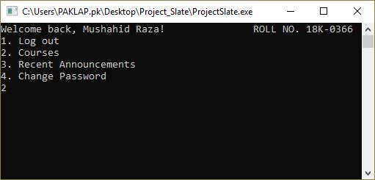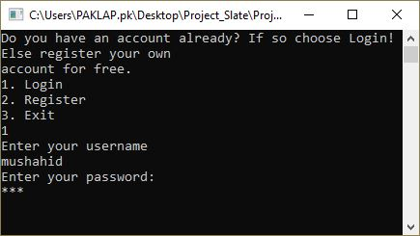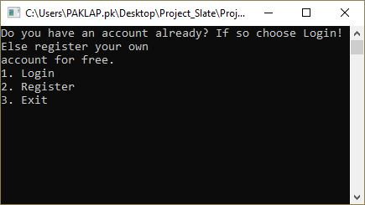

Program starts by giving user a choice to login if he/she has already registered in the past, to register if he/she is a new user or just exit the program

If choice is 1, then it prompts user to input his/her unique username and password and itself recognizes whether the user is teacher or student

After successful login it will show user his/her name and unique roll no. and show menu of courses, recent announcements and option of change password. The user is again to make choice

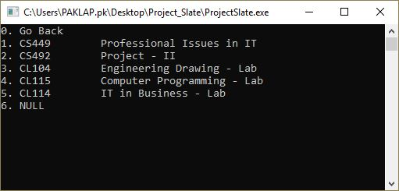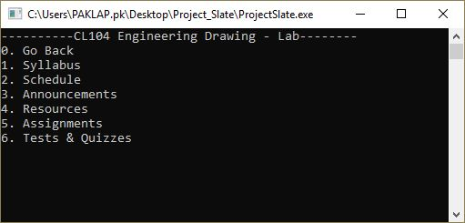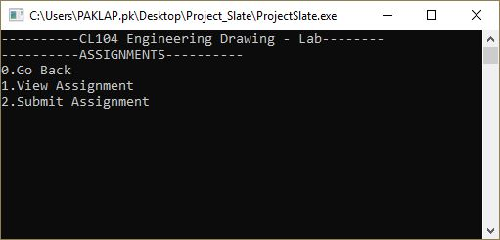

If user selects courses the program recognizes the semester of student/subject of teacher itself and displays the relative courses only.

As soon as the sub-function of function is complete the function is called back… with 0 given a choice to go back on previous page as well.

Each Function has its own menu according to its specific need. There is an example of “Assignment” function as you can see on the figure on left of this dialogue box.

With the selection of subject, these functions are provided and when selected… proper function is called…

**TEST # 02**

|  |  |
| --- | --- |
| Title | The Registration |
| Identification | The program is dynamic and can get new users as well |
| Decision | **OK** |
| Comment (If Any) |  |

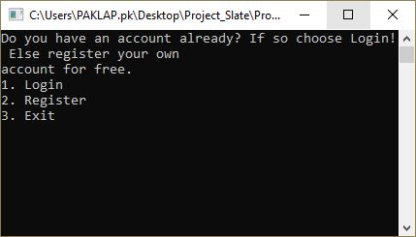

If choice is 2, then it program directly goes in registration mode. Where is asks user for details and add them in database for future login

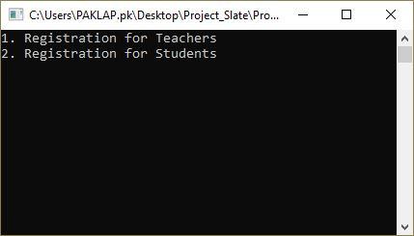

As soon as 2 is entered, the user is prompted to choose whether he/she wants to register as a teacher or student

***PTO…***

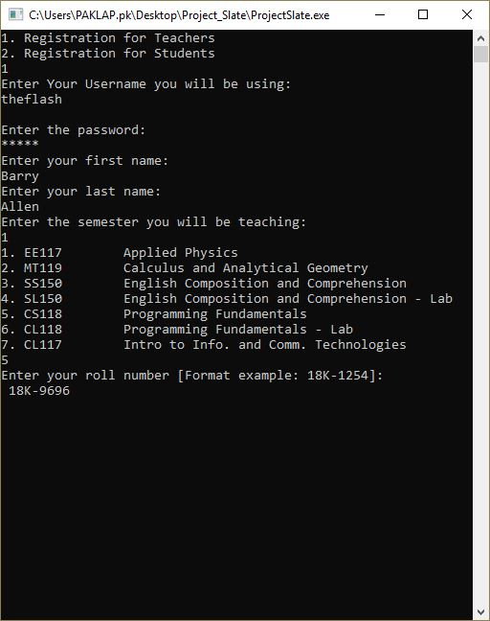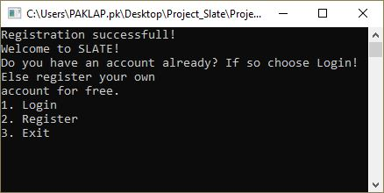

As soon as choice is entered, the user is prompted to enter his/her relevant detail with minor changes if teacher or student and the data is stored in a file for future use

As soon as the user enters his final detail… registration successful message is prompted. Obviously all his details is validated through check. And main function is called back